WEEK – 11

1# Create an inter University Database with the following relations.
Include at least four attributes for each table.
• University
• Department
• Program
• Course
• Syllabus
• Faculty (Teacher)

- Create ER Diagram and Schema diagram for the above system.
*Attached at end
b) Create above tables and mention primary keys and foreign keys. Also create secondary index for each table
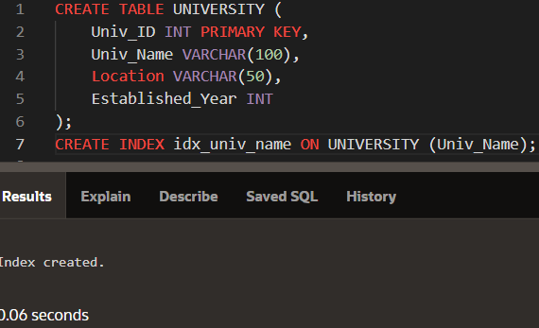
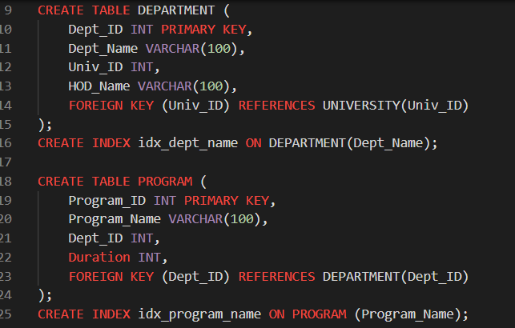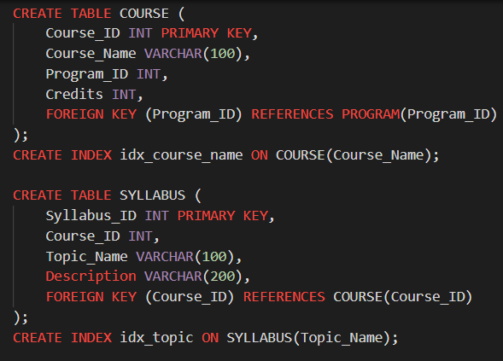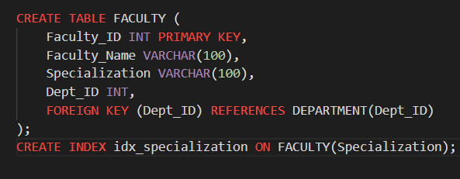

- Insert at least 5 relevant records in each of the created tables.
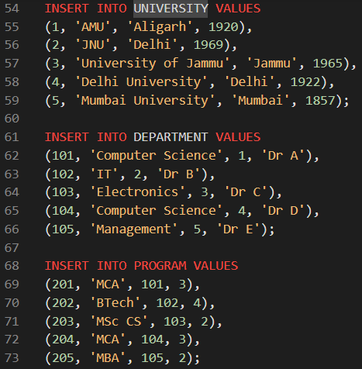
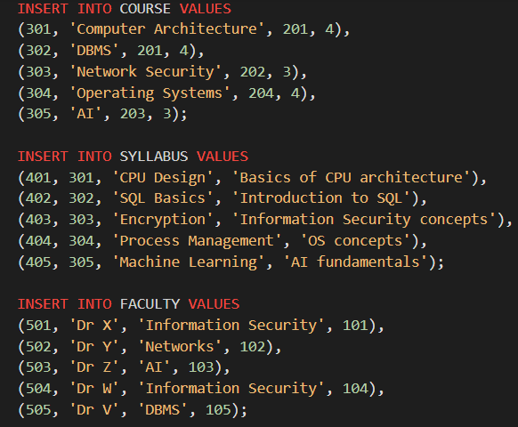

d) Write following SQL queries based on above created database:
i) List of Universities situated at Mumbai.
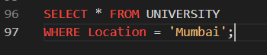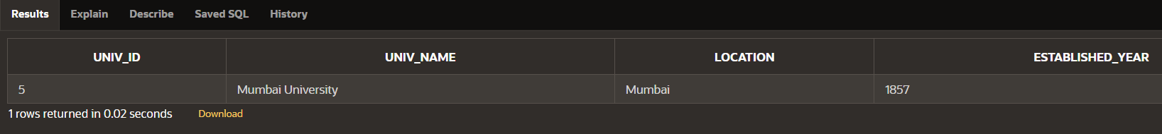
ii) List of all the programs run by the AMU.
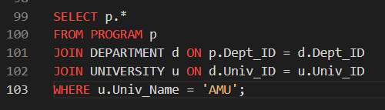
iii) Find out all the departments of JNU.
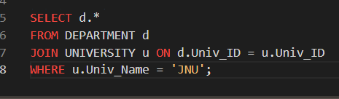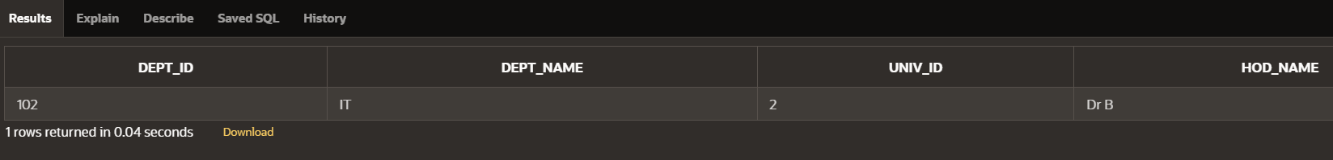

iv) List of all Programs run by University of Jammu
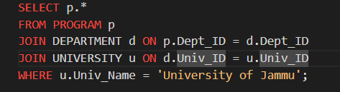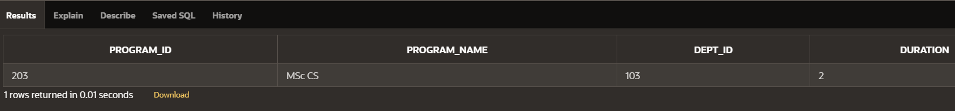
v) List of Universities that run Program "MCA".
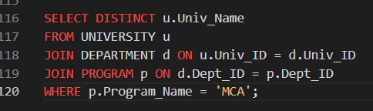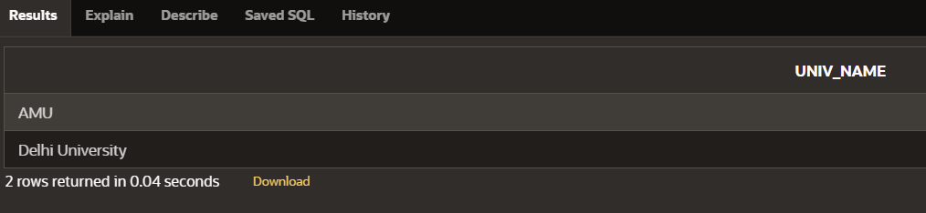
vi) List of Courses of "MCA" run by AMU.
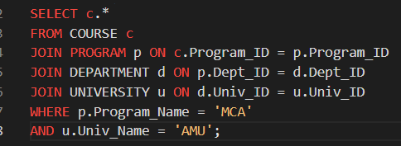
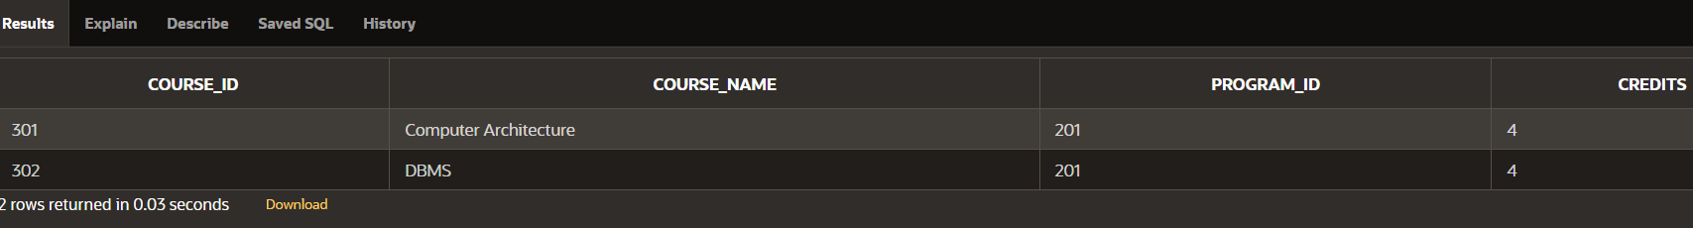
vii) List of Faculties specialized in "Information Security"
across different universities.
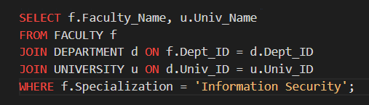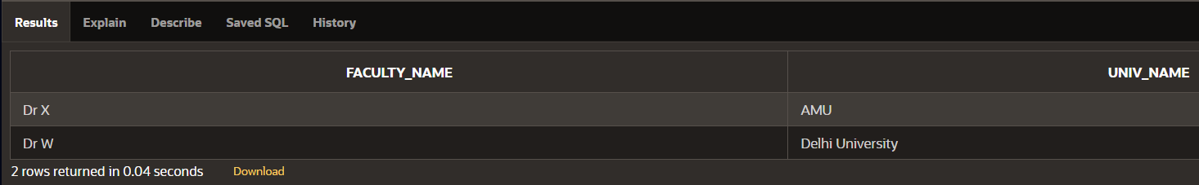
viii) Syllabus of "Computer Architecture" of different Universities.
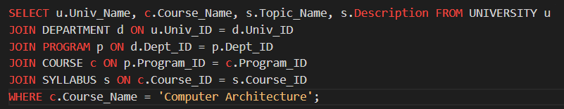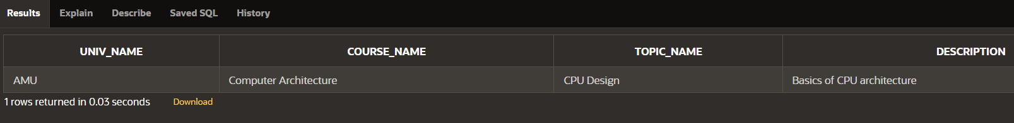
ix) List of all faculties with their specializations of Department of Computer Science of Delhi University.
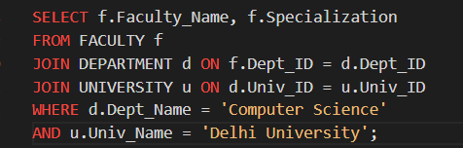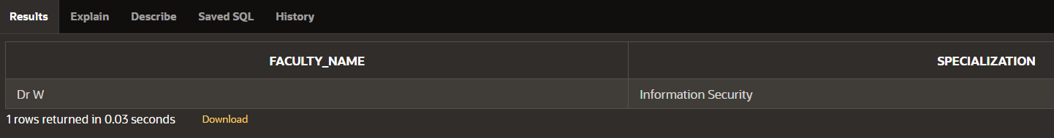

x) Find the University running maximum programs
